

Doctor-X

Documents

Team 1:

Documents in clude :   
- System requirements software

- Screen Design

- Architecture Design  
- Data Design

- Test case

 TRƯỜNG CAO ĐẲNG CÔNG NGHỆ THỦ ĐỨC

**KHOA CÔNG NGHỆ THÔNG TIN**

**Tài liệu Chuyên đề di động 1**

**Lập trình di động Android**

**Xây dựng ứng dụng “Doctor-X”**

**Giảng viên hướng dẫn: Tiêu Kim Cương**

**Sinh viên thực hiện: Nhóm 1**

1. **Nguyễn Nguyên Thành Đạt**
2. **Hồ Nhật Hậu**
3. **Nguyễn Minh Khánh**
4. **Trần Cao Vinh**

**Khoa: Công nghệ thông tin Khóa: 2015**

**Ngày 20/03/2018**

**NHẬT KÝ HOẠT ĐỘNG NHÓM 1**

|  |  |  |  |  |
| --- | --- | --- | --- | --- |
| **STT** | **HỌ TÊN** | **CÔNG VIỆC** | **NHÓM**  **ĐÁNH GIÁ** | **KÝ TÊN** |
| **1** | Nguyễn Nguyên Thành Đạt | Nghiêm cứu đề tài  Viết SRS  Viết SDS  Viết báo cáo  Viết testcase  Code màn hình | 25% |  |
| **2** | Hồ Nhật Hậu | Nghiêm cứu đề tài  Viết SRS  Viết SDS  Viết báo cáo  Viết testcase  Code màn hình | 25% |  |
| **3** | Nguyễn Minh Khánh | Nghiêm cứu đề tài  Viết SRS  Viết SDS  Viết báo cáo  Viết testcase  Code màn hình | 25% |  |
| **4** | Trần Cao Vinh | Nghiêm cứu đề tài  Viết SRS  Viết SDS  Viết báo cáo  Viết testcase  Code màn hình | 25% |  |

TABLE OF CONTENTS



**Application: Doctor-X**

**Version: 1.0**

Note :This is no offical document.

Document can be change in next version. Documents can only be referenced.

.

**Revision History**

| Date | Version | Description | Author | Revised by |
| --- | --- | --- | --- | --- |
| 12/03/2018 | 1.0 | System requirement specification | Ho Nhat Hau | Group 1 |
|  |  |  |  |  |
|  |  |  |  |  |
|  |  |  |  |  |
|  |  |  |  |  |

Table of Contents

1. Introduction 6

1.1 Overview 6

1.2 Scope 6

2. Functional Requirements 7

2.1 Feature/Component #1: Registration screen 7

2.1.1 User Interfaces 7

2.1.2 Functional Requirements 7

2.2 Feature/Component #2: Login Screen 9

2.2.1 User Interfaces 9

2.2.2 Functional Requirements 9

2.3 Feature/Component #3: Select type account 10

2.3.1 User Interfaces 10

2.3.2 Functional Requirements 10

2.4 Feature/Component #4: Patient information setting screen 11

2.4.1 User Interfaces 11

2.4.2 Functional Requirements 11

2.5 Feature/Component #5: Doctor information setting screen 13

2.5.1 User Interfaces 13

2.5.2 Functional Requirements 13

2.6 Feature/Component #6: Patient Main Screen 14

2.6.1 User Interfaces 15

2.6.2 Functional Requirements 15

2.7 Feature/Component #7: Doctor Main Screen 16

2.7.1 User Interfaces 16

2.7.2 Functional Requirements 16

2.8 Feature/Component #8: Search doctor screen 17

2.8.1 User Interfaces 17

2.8.2 Functional Requirements 17

2.9 Feature/Component #9: Search Result Doctors Screen 19

2.9.1 User Interfaces 19

2.9.2 Functional Requirements 19

2.10 Feature/Component #10: Service in maps 20

2.10.1 User Interfaces 20

2.10.2 Functional Requirements 20

2.11 Feature/Component #11: Book doctor screen 20

2.11.1 User Interfaces 21

2.11.2 Functional Requirements 21

2.12 Feature/Component #12: Find doctor in emergency 21

2.12.1 User Interfaces 22

2.12.2 Functional Requirements 22

2.13 Feature/Component #13: Search doctor 23

2.13.1 User Interfaces 23

2.13.2 Functional Requirements 23

2.14 Feature/Component #14: Details information of doctor 24

2.14.1 User Interfaces 24

2.14.2 Functional Requirements 24

2.15 Feature/Component #15: Doctor is coming in patient screen 25

2.15.1 User Interfaces 25

2.15.2 Functional Requirements 25

2.16 Feature/Component #16: Details status of patient in emergency 26

2.16.1 User Interfaces 26

2.16.2 Functional Requirements 26

2.17 Feature/Component #17: Doctor is coming in doctor screen 27

2.17.1 User Interfaces 27

2.17.2 Functional Requirements 27

# Introduction

## Overview About Doctor-X. So Doctor-X can help anybody have problem about healthy. In Doctor-X patient can find any doctor nearby them in radius with 20 kilometer. List doctor nearby them will show and you can choose anybody they feel good for themselves. In additions, we can save any doctor for emergency. In application, have full information about doctor like as : Phone number , email , work at,. Etc. So patient can contact doctor anytime they can. In application, we provided address hospital ,etc. So have a thing indispensable is healthy tips and medicine reminder . So we hope Doctor-X will useful for everybody . Thank you !

## Scope

***Android version: to 5.1 upwards.***

* ***Android test devices: Samsung Galaxy A5.***

***Android screen resolutions: 720x1280***

***Only vertical***

***Must be turn on GPS , data 3g or wifi***

# Functional Requirements

## Feature/Component #1: Registration screen

### User



*Image 1: Registration screen*

### Functional Requirements

|  |  |  |  |
| --- | --- | --- | --- |
| **Item** | **Description** | **Action** | **Response** |
| **Registration screen** | Register Screen has 4 fields and 1 button:   * Field for input phone number * Field for input user name * Field for input password * Field for input email * Button create account | N/A | N/A |
| **Field for input phone number** | Field hold phone number of user | Input field  Password  Email | User complete input phone number and forward next step |
| **Field for input user name** | Field hold user name | Input field | User complete input user name and forward next step |
| **Field for input password** | Field hold password | Input field | User complete input user name and forward next step |
| **Field for input email** | Field hold password | Input field | User complete input emai and forward next step |
| **Create account button** | After the user finishes typing in all steps, click on button to proceed to create account | Press button | Make an email confirmation and complete the registration |

## Feature/Component #2: Login Screen

### User Interfaces

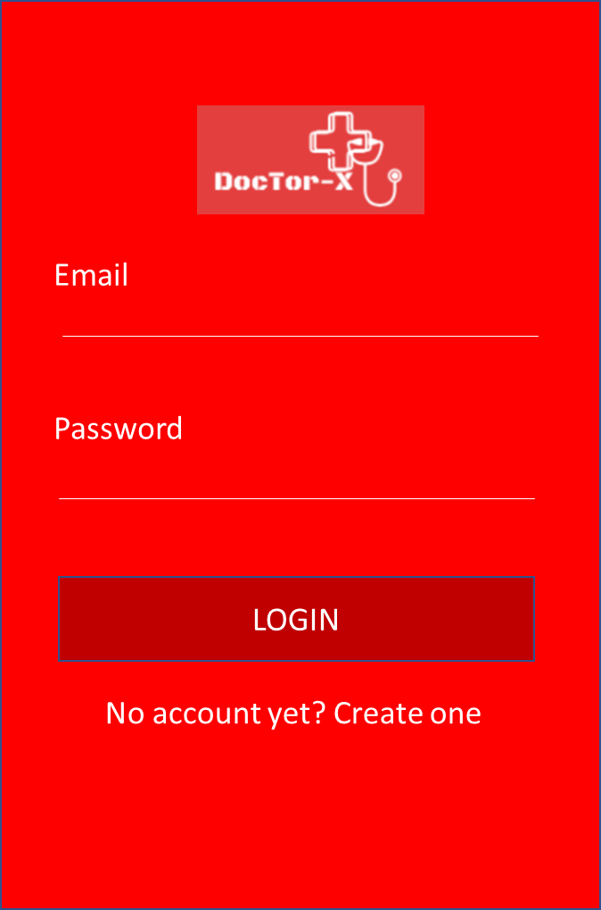

*Image2: Login screen*

### Functional Requirements

|  |  |  |  |
| --- | --- | --- | --- |
| **Item** | **Description** | **Action** | **Response** |
| LoginScreen | Login screen has 2 field for input, 1 button, 1 link   * 1 field for input email * 1 field for input password * 1 button for login * 1 link connect to registration screen if user hasn’t account | N/A | N/A |
| Field for input email | Field hold email of user | Input field | User complete input email and forward next step |
| Field for input password | Filed hold password | Input field | User complete input password and forward next step |
| Button login | After the user finishes typing in all steps, click on button to proceed to login | Press button | Go to the user account type screen |
| Link registration | If the user does not have an account, click on the link will go to the registration screen | Press link | Go to registration screen |

## Feature/Component #3: Select type account

### User Interfaces

*Image3: Select type account screen*

### Functional Requirements

|  |  |  |  |
| --- | --- | --- | --- |
| **Item** | **Description** | **Action** | **Response** |
| **Select account type** | Select account type has 2 button:   * 1 button for select account type is patient * 1 button for select account type is doctor | N/A | N/A |
| **Button for select account type is patient** | The button used to transfer the account information settings is the patient | Press button | Go to the patient information settings screen |
| **Button for select account type is doctor** | The button used to transfer the account information settings is the doctor | Press button | Go to the doctor information settings screen |

## Feature/Component #4: Patient information setting screen

### User Interfaces

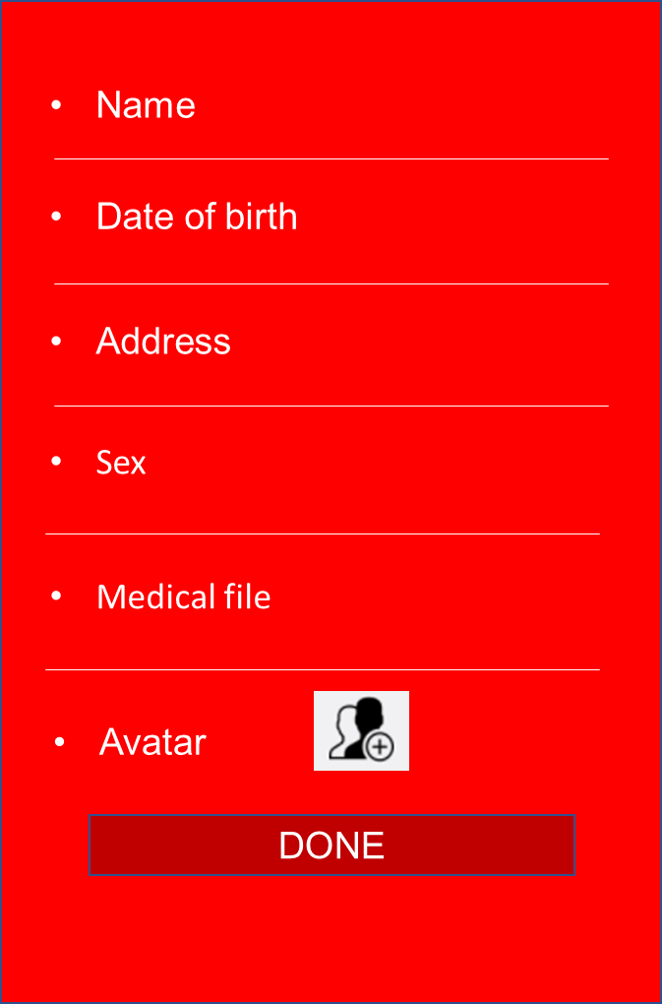

*Image4:* **Patient information setting screen**

### Functional Requirements

|  |  |  |  |
| --- | --- | --- | --- |
| **Item** | **Description** | **Action** | **Response** |
| **Patient information setting screen** | Patient information has 4 fields and 3 button:   * 1 field for input full name of user * 1 button for select date of birth * 1 field for input address * 1 button for select sex * 1 field for input medical file * 1 field for update avatar * 1 button to complete setting | N/A | N/A |
| **Field for input full name of user** | Field hold full name of patient | Input field | User complete input full name and forward next step |
| Button for select date of birth | Button allow user select date of birth in the form datetimepicker | Press button | Shown as datetimepicker and let users choose their date of birth |
|  |  |  |  |
| Field for input address | Field hold address of patient | Input field | User complete input address and forward next step |
| Button for select sex | Button allow user select their sex in the form radio button | Choose button | User select only one button in the select sex |
| Field for input medical file | Field hold medical file of patient | Input field | User complete input medical file and forward next step |
| Field for update avatar of user | Field hold avatar of patient | Press field | When user press field then go to library of user phone for update avatar |
| Button to complete setting | After the user finishes typing in all steps, click on button to proceed to setting profile | Press button | Go to main screen |

## Feature/Component #5: Doctor information setting screen

### User Interfaces

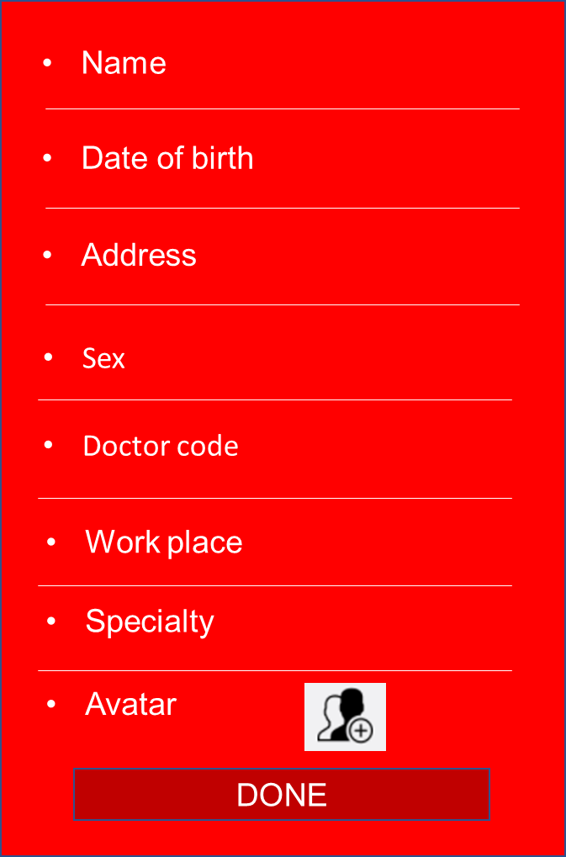

*Image5: Doctor information setting screen*

### Functional Requirements

|  |  |  |  |
| --- | --- | --- | --- |
| **Item** | **Description** | **Action** | **Response** |
| **Doctor information setting screen** | Doctor information setting screen has 5 fields and 4 button   * 1 field for input full name of doctor * 1 button for select date of doctor * 1 field for input address of doctor * 1 button for select sex of doctor * 1 field for input work place of doctor * 1 button for select specialist of doctor * 1 field for input doctor code * 1 field for select avatar of doctor * 1 button to complete setting | N/A | N/A |
| **Field for input full name of doctor** | Field hold full name of doctor | Input field | Doctor complete input full name and forward next step |
| Button for select date of birth | Button allow doctor select date of birth in the form datetimepicker | Press button | Shown as datetimepicker and let doctors choose their date of birth |
| Field for input address | Field hold address of doctor | Input field | Doctor complete input address and forward next step |
| Button for select sex | Button allow user select their sex in the form radio button | Choose button | Doctor select only one button in the select sex |
| Field for input doctor code | Field hold doctor code | Input field | Doctor complete input address and forward next step |
| Field for input work place | Field hold work place of doctor | Input field | Doctor complete input work place and forward next step |
| Field for update avatar of doctor | Field hold avatar of doctor | Press field | When user press field then go to library of doctor phone for update avatar |
| Button to complete setting | After the user finishes typing in all steps, click on button to proceed to setting profile | Press button | Go to main screen |

## Feature/Component #6: Patient Main Screen

### User Interfaces

*Image6: Main screen of patient*

### Functional Requirements

|  |  |  |  |
| --- | --- | --- | --- |
| **Item** | **Description** | **Action** | **Response** |
| **Patient main screen** | Patient main screen has 6 buttons and navigation bar:   * Book appointment * Call ambulance * Health tips * Find doctor * Find hospital * Medicine reminder * Navigation bar | N/A | N/A |
| **Navigation bar** | Navigation bar hold menu and button back step before | Press item of bar | Move to user-selectable functions |
| **Button book appointment** | Make an appointment with your doctor at home | Press button | Move to book appointment screen |
| **Button call ambulance** | Used to call an ambulance | Press button | Move to call ambulance screen |
| **Button health tips** | Contain health tips | Press button | Move to health tips screen |
| **Button find doctor** | Used to look for doctors in the scan radius of the user's phone | Press button | Move to find doctor screen |
| **Find hospital** | Used to look for hospitals in the scan radius of the user's phone | Press button | Move to find hospital screen |
| **Button medicine reminder** | Remind patients taking medication | Press button | Move to medicine reminder screen |

## Feature/Component #7: Doctor Main Screen

### User Interfaces



*Image7: Doctor main screen*

### Functional Requirements

|  |  |  |  |
| --- | --- | --- | --- |
| **Item** | **Description** | **Action** | **Response** |
| **Doctor main screen** | Doctor main screen has 5 button:   * Appointment * My patient * History * Profile * Find patient direction | N/A | N/A |
| **Button Appointment** | Allow doctor watch appointments of their | Press button | Move to appointment screen |
| **Button My patient** | Allow doctor watch the patients receiving treatment | Press button | Move to my patient screen |
| **Button History** | Allow doctor watch all their patient have been and are being treated | Press button | Move to History screen |
| **Button Profile** | Allow doctor watch and update their information | Press button | Move to Profile screen |
| **Button Search patient direction** | Allow doctor find patient in the scan radius of the user's phone | Press button | Move to Search patient direction screen |

## Feature/Component #8: Search doctor screen

### User Interfaces



*Image8: Search doctor*

### Functional Requirements

|  |  |  |  |
| --- | --- | --- | --- |
| **Item** | **Description** | **Action** | **Response** |
| **Search doctor screen** | Search doctor screen has 4 fields and 2 button:   * Field select specialty * Field your position * Field Type of appointment * Time * Button Picture description * Button Search | N/A | N/A |
| **Field Select specialty** | This field show under form dropdown  with specialists available | Press field and select 1 of the fields | Patients will choose the specialty they want to choose |
| **Your position** | This field allow user select their position in maps | Press field and input position | User position will show in maps |
| **Type of appointment** | This field allow user select type of appointment (2 type: normal, emergency) show under form dropdown | Press field and select 1 in 2 fields | Patients will choose type of appointment they want to choose |
| **Time** | With case normal user will select time for appointment | Press field and select time | User will choose time for appointment |
| **Picture description** | User will have images describe their status let the doctor see the situation clearly | Press button and select images in library of user’s phone | The user will select the image that is descriptive of their case |
| **Button search** | After completing the above steps user will proceed search | Press button | Move to search result screen |

## Feature/Component #9: Search Result Doctors Screen

### User Interfaces

*Image9: Search result doctors*

### Functional Requirements

|  |  |  |  |
| --- | --- | --- | --- |
| **Item** | **Description** | **Action** | **Response** |
| **Search result doctors** | Search result doctors has 2 section:   * Maps and positon of doctors in maps * Information of doctors | N/A | N/A |
| **Maps** | Show position of doctors that the user's phone is scanned | Press on position in maps | User will search doctors in line with their medical needs |
| **Information of doctor** | Show information of doctors searched | Press on 1 of doctors found | User will watch detail information of doctors their choose |

## Feature/Component #10: Service in maps

### User Interfaces

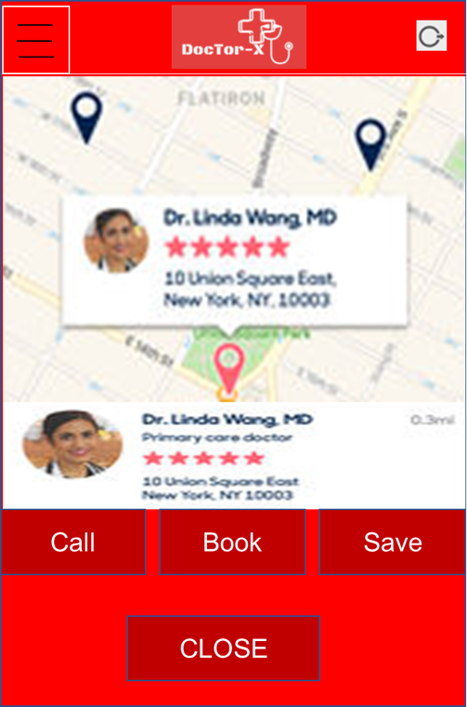

*Image10: Service in maps*

### Functional Requirements

|  |  |  |  |
| --- | --- | --- | --- |
| **Item** | **Description** | **Action** | **Response** |
| **Service in maps screen** | Screen has 1 section show positon of doctor, 4 button:   * Call * Book * Save * Close | N/A | N/A |
| **Section positon of doctor** | Full display of doctor's information, location, distance from doctor | Press on maps | When user press on maps will see  specific location of doctor |
| **Button Call** | Use call doctor | Press button | Move to call screen of user’s phone |
| Button Book | Use make an appointment with doctor  If the patient wants to have a home visit | Press button | Move to appointment screen |
| Button Save | Use save information of doctor | Press button | Information of doctor will be saved |
| Button close | Back previous step | Press button | Moved to Search result doctor screen |

## Feature/Component #11: Book doctor screen

### User Interfaces



*Image11: Book doctor*

### Functional Requirements

|  |  |  |  |
| --- | --- | --- | --- |
| **Item** | **Description** | **Action** | **Response** |
| **Book doctor screen** | Screen has 2 section:   * Maps * Appointment | N/A | N/A |
| **Maps** | Show location of doctor | N/A | N/A |
| **Appointment** | Show appointment of patient with doctor | N/A | N/A |

## Feature/Component #12: Find doctor in emergency

### User Interfaces

*Image12: Search doctor in emergency case*

### Functional Requirements

|  |  |  |  |
| --- | --- | --- | --- |
| **Item** | **Description** | **Action** | **Response** |
| **Find doctor in emergency screen** | Screen has 2 field, 2 button | N/A | N/A |
| **Field for input location** | For user input location have an accident | Input field | User input true location |
| **Note** | Input current status | Input field | User input about current status |
| **Button Picture description** | Post pictures to describe | Press button | User post pictures to describe about current status |
| **Button Search** | Conducting the search | Press button | Seek immediate medical attention |

## Feature/Component #13: Search doctor

### User Interfaces

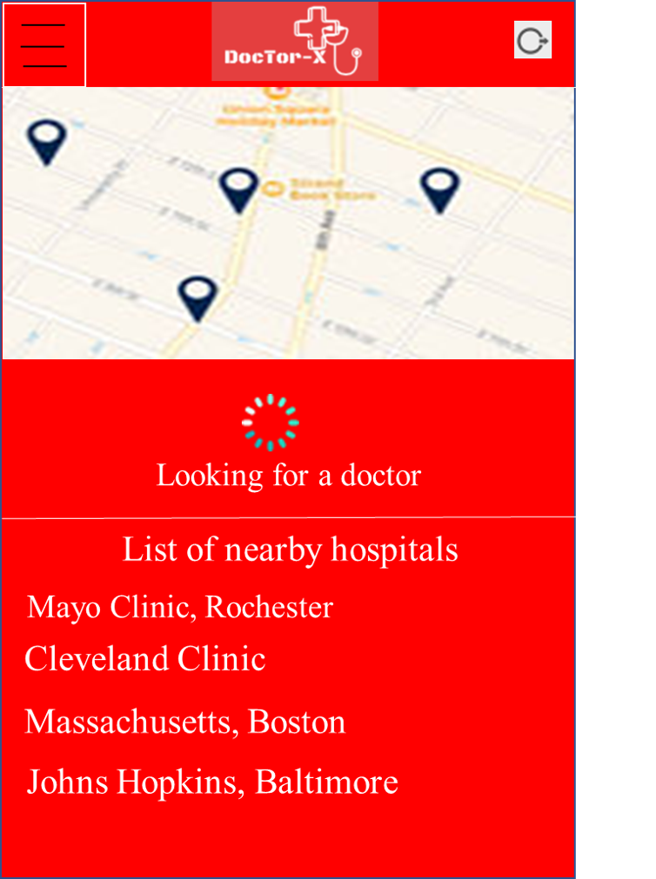

*Image13: Search doctor*

### Functional Requirements

|  |  |  |  |
| --- | --- | --- | --- |
| **Item** | **Description** | **Action** | **Response** |
| **Search doctor** | Screen has 2 section:   * Maps * List hospitals | N/A | N/A |
| **Maps** | Look all doctors location | Press maps | User watch information of doctor in maps |
| **List hospitals** | Show list hospital near user | N/A | N/A |

## Feature/Component #14: Details information of doctor

### User Interfaces

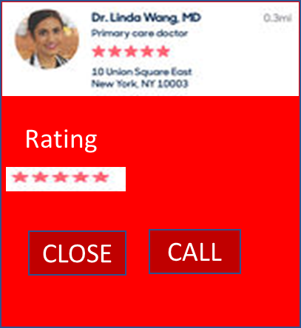

*Image14: Details information of doctor*

### Functional Requirements

|  |  |  |  |
| --- | --- | --- | --- |
| **Item** | **Description** | **Action** | **Response** |
| **Details information of doctor screen** | Screen has 2 section:   * Information of doctor * Buttons: Call, Close | N/A | N/A |
| **Information of doctor** | About information: Name of doctor, Specialty, Address, Rating and Review | N/A | N/A |
| **Button Call** | Call to doctor | Press button | Move to call screen of user’s phone |
| **Button Close** | Exit and previous step | Press button | Back to previous screen |

## Feature/Component #15: Doctor is coming in patient screen

### User Interfaces

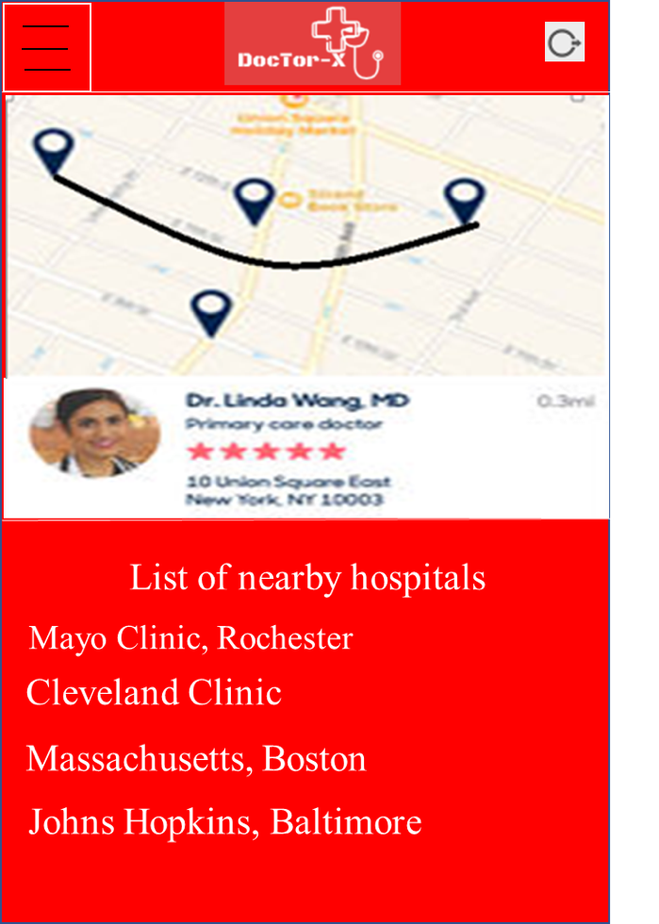

*Image15: Doctor is coming*

### Functional Requirements

|  |  |  |  |
| --- | --- | --- | --- |
| **Item** | **Description** | **Action** | **Response** |
| **Doctor is coming screen** | Screen has 2 section:   * Maps * List of near hospitals | N/A | N/A |
| **Maps** | Show location of doctor with patient | Press maps | User will watch details location of doctor with their if plus zoom map |
| **List of near hospitals** | Show list near hospitals | N/A | N/A |

## Feature/Component #16: Details status of patient in emergency

### User Interfaces

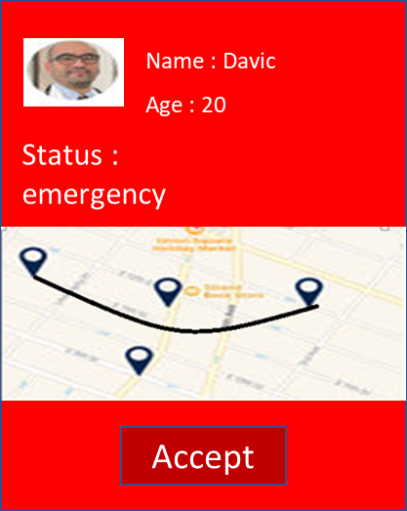

*Image16: Details status of patient*

### Functional Requirements

|  |  |  |  |
| --- | --- | --- | --- |
| **Item** | **Description** | **Action** | **Response** |
| **Details status of patient in emergency screen** | Screen has 2 section:   * Status of patient * Button: Accept, Location of patient | N/A | N/A |
| **Status** | Show details status of patient | N/A | N/A |
| **Button Location of patient** | Show location of patient in maps | Press button | Doctor will watch location of patient |
| **Button Accept** | Use accept requirement of patient | Press button | When doctor accept phone of patient will notify doctor to confirm |

## Feature/Component #17: Doctor is coming in doctor screen

### User Interfaces

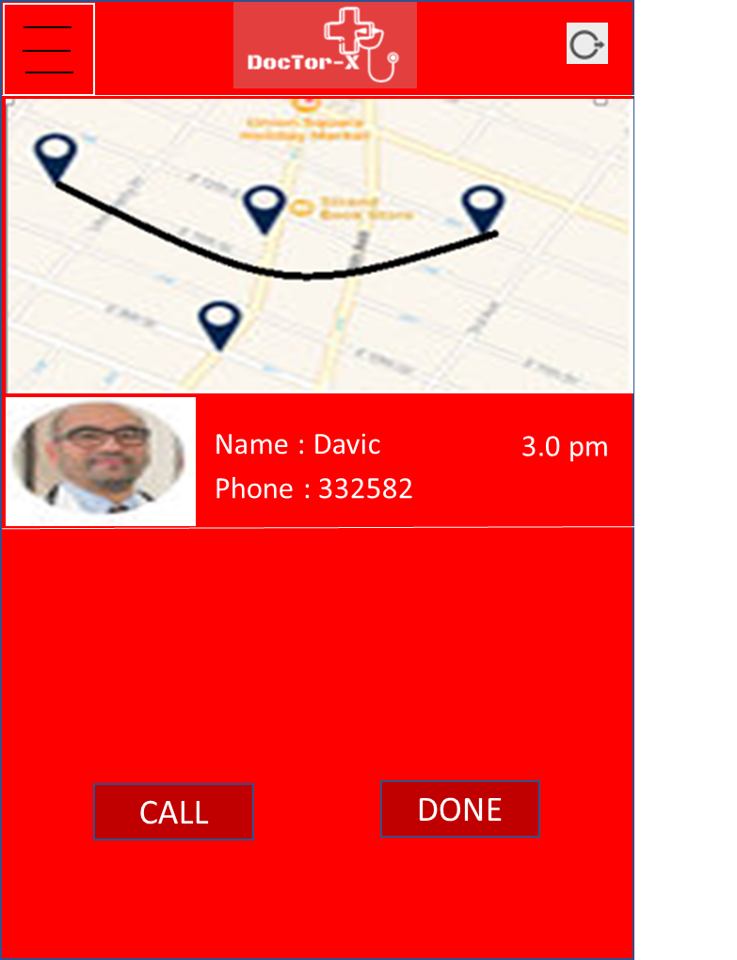

*Image17: Doctor is coming*

### Functional Requirements

|  |  |  |  |
| --- | --- | --- | --- |
| **Item** | **Description** | **Action** | **Response** |
| **Doctor is coming in doctor screen** | Screen has 3 section:   * Maps * Information of patient * Button: Call, Done | N/A | N/A |
| **Maps** | Show distance of doctor and patient | Press maps | When doctor press on maps will watch details |
| **Information of patient** | Show information of patient | N/A | N/A |
| **Button Call** | Allow doctor calling patient | Press button | Move to call screen of doctor’s phone |
| **Button Done** | After doctor completed treatment | Press button | Doctor completed treatment with patient and save information of patient in history |